UNIVERSITY OF ENERGY AND NATURAL RESOURCES



EFFECT OF SEA SURFACE TEMPERATURE ON RAINFALL OVER GHANA

ARTHUR RICHARD

&

ABUUD MARIAM

SCHOOL OF GEOSCIENCES

DEPARTMENT OF ATMOSPHERIC AND CLIMATE SCIENCE

UNIVERSITY OF ENERGY AND NATURAL RESOURCES

SUNYANI, GHANA

EFFECT OF SEA SURFACE TEMPERATURE ON RAINFALL OVER GHANA

BY

ABUUD MARIAM

UEB1303919

AND

ARTHUR RICHARD

UEB1302219

A THESIS SUBMITTED TO THE DEPARTMENT OF ATMOSPHERIC AND CLIMATE SCIENCE, SCHOOL OF GEOSCIENCES, UNIVERSITY OF ENERGY AND NATURAL RESOURCES, SUNYANI, GHANA IN PARTIAL COMPLETION OF THE REQUIREMENT FOR THE DEGREE IN BACHELOR OF SCIENCE IN CLIMATE CHANGE AND SUSTAINABLE DEVELOPMENT.

SEPTEMBER, 2023

# 

# **DECLARATION**

We hereby declare that this thesis is our own work towards the award of BSc. Climate Change and Sustainable Development in the Department of Atmospheric and Climate Science, University of Energy and Natural Resources, and that, to the best of our knowledge, it encompasses no material beforehand published by another person nor material which has been accepted for the award of any other degree in the University, excluding where due acknowledgment has been made to the writing.

|  |  |  |
| --- | --- | --- |
| Abuud Mariam | ………………………. | ……………………. |
| (Student) | Signature | Date |

|  |  |  |
| --- | --- | --- |
| Arthur Richard | ………………………. | ……………………. |
| (Student) | Signature | Date |

|  |  |  |
| --- | --- | --- |
| Dr. Naomi Kumi | ……………………… | ……………………… |
| (Supervisor) | Signature | Date |

Dr. Nana Agyeman Prempeh …………………… ……………………….

(Head of Department) Signature Date

# **DEDICATION**

First of all, we dedicate this thesis to the Almighty God and our parents for their support and encouragement during this project work. May the Almighty God bless you. We hereby declare our unwavering commitment to our work, driven by passion and determination. We approach our tasks daily with a sense of purpose, striving for excellence in everything we do. We believe that our work is not merely a means of earning a living, but a reflection of our values and aspirations. We are dedicated to continuous growth and learning, constantly seeking new knowledge and skills to enhance our expertise. We embrace challenges as opportunities for personal and professional development, never shying away from pushing boundaries or thinking outside the box. Moreover, we value collaboration and teamwork, recognizing that the collective effort of a diverse group yields the greatest results. we actively foster an environment of respect, open communication, and inclusivity, where ideas are freely shared and celebrated. We are also committed to making a positive impact through my work. Whether it be by creating innovative solutions, inspiring others, or contributing to a greater cause, we strive to leave a lasting imprint on Ghana, West Africa, Africa, and the world as a whole.

# **ACKNOWLEDGEMENT**

We would like to express our sincere gratitude and appreciation to all those who have contributed to the successful completion of our research on the topic, The Effect of Sea Surface Temperature on Rainfall Over Ghana.

First and foremost, we would like to extend our heartfelt thanks to our supervisor, Dr. Naomi Kumi for her invaluable guidance, support, and encouragement throughout this research journey. Her expertise and insights have been instrumental in shaping the direction of this study. We are also deeply thankful to Dr. Frederick Otu-Larbi and the faculty members of the University of Energy and Natural Resources, especially the Department of Atmospheric and Climate Science, for providing us with the necessary resources and facilities to conduct this research. Their commitment to academic excellence has greatly enriched our learning experience. Their efforts have significantly contributed to the reliability and validity of our findings. We are particularly grateful to the Ghana Meteorological Agency for providing access to their datasets.

We are indebted to our family and friends for their unwavering support and understanding throughout this research endeavor. Their constant encouragement and belief in us have been a source of inspiration during challenging times.

Lastly, we would like to express our gratitude to all the researchers and scholars whose works we have referenced in this study. Their ground-breaking research has paved the way for further exploration into the relationship between sea surface temperature and rainfall patterns, providing a solid foundation for our investigation. In conclusion, this research would not have been possible without the collective effort and support of all those mentioned above. We are truly grateful for their contributions, and we hope that this study will contribute to the existing body of knowledge on climate dynamics in Ghana.

# **ABSTRACT**

This study investigates how Ghanaian rainfall patterns are impacted by sea surface temperature (SST). The goal of the study is to comprehend the connection between rainfall variability and SST as well as how changes in SST may affect Ghana's climate. Using historical SST and rainfall data from reliable sources, the study examines the relationship between these variables over a certain time period. According to preliminary data, Ghana's SST and rainfall have a significant relationship. Higher SSTs are associated with more precipitation, while lower SSTs are associated with drier conditions. This association is more noticeable during specific seasons or months, suggesting that the SST-rainfall relationship is influenced by seasonal factors. The study also looks into the possible processes underlying this connection. It investigates how interactions between the ocean and atmosphere, such as the El Nio–Southern Oscillation (ENSO) phenomena, affect SST and the ensuing patterns of precipitation. Additionally, regional elements like coastal upwelling and land-sea wind circulation are taken into account as potential sources of rainfall variability. It is critical for a number of industries, including agriculture, water resource management, and disaster planning, to comprehend how SST affects rainfall in Ghana. The results of this study can help guide decision-making, empowering stakeholders and policymakers to create successful policies for climate adaptation and mitigation. Exploring the long-term patterns and outlook for SST-rainfall connections in Ghana will require more research. This will help in the formulation of preventative strategies to deal with possible difficulties and offer insightful information on how climate change may affect rainfall patterns. This study's result emphasizes the importance of the relationship between Ghana's rainfall variability and sea surface temperature. It underlines the requirement for ongoing analysis and preventative efforts to lessen the potential effects of shifting SST on the nation's climate and socioeconomic health.

# **TABLE OF CONTENT**

**DECLARATION i**

**DEDICATION ii**

**ACKNOWLEDGEMENT iii**

**ABSTRACT iv**

**CHAPTER ONE 1**

**INTRODUCTION 1**

**1.1 Background of the study 1**

**1.2 Problem Statement 4**

**1.3 Justification of the Study 5**

**1.4 Aims and Objectives 6**

**1.4.1 Aim 6**

**1.4.2 Specific Objectives 6**

**1.5 Research Questions 6**

**1.6 Thesis Structure 7**

**CHAPTER TWO 8**

**LITERATURE REVIEW 8**

**2.1 Theoretical Framework 9**

**2.1.1 The Ocean Heat Transport Theory 9**

**2.1.2 The Atmosphere-Ocean Coupling Theory 10**

**2.1.3 The Solar Radiation Theory 11**

**2.1.4 The Thermocline Theory 13**

**2.2 Understanding Sea Surface Temperature 14**

**2.3 Measurement of Sea Surface Temperature 15**

**2.4 Effects of Sea Surface Temperature On Rainfall 17**

**2.4.1 Climate Patterns and Atmospheric Circulation 17**

**2.4.2 Coral Reefs and Ecosystem Disruption 17**

**2.4.3 Species Distribution and Marine Ecosystems 18**

**2.4.4 Extreme Weather Events and Tropical Cyclones 18**

**2.4.5 Ocean Acidification 19**

**2.4.6 Sea-Level Rise 19**

**2.5 Understanding Rainfall 19**

**2.6 Rainfall Variations in Ghana 21**

**2.7 Importance of Rainfall In Ghana 22**

**2.7.1 Agriculture 22**

**2.7.2 Water Resources 23**

**2.7.3 Hydropower Generation 23**

**2.7.4 Maintaining Ecological Balance and Biodiversity 23**

**2.7.5 Erosion and Soil Conservation 24**

**2.8 The Relationship Between SST And Rainfall in Ghana 24**

**CHAPTER THREE 26**

**DATA AND METHODOLOGY 26**

**3.1 Description of The Study Area 26**

**3.2 Data 28**

**3.3 Methodology 29**

**CHAPTER FOUR 30**

**RESULTS AND DISCUSSIONS 30**

**4.1 Analysis of SST and Rainfall over Accra and Axim. 31**

**4.2 Analysis of Annual SST and Rainfall in Sunyani and Kete-Krachi 32**

**4.3 Analysis of Annual SST and Rainfall over Bole and Navrongo 34**

**4.4 Analysis of SST and Rainfall over Koforidua and Kumasi 35**

**4.5 Analysis of Sea Surface Temperature and Rainfall over Tamale and Yendi 37**

**4.6 Analysis of Sea Surface Temperature and Rainfall over Kete-Krachi and Sunyani 39**

**CHAPTER FIVE 41**

**CONCLUSION AND RECOMMENDATIONS 41**

**5.1 Conclusion 41**

**5.2 Recommendation 42**

**REFERENCES 43**

# **LIST OF TABLES**

Table 3.1 The various synoptic stations in Ghana and points (in the Atlantic Ocean) used in the study. 27

Table 3.2 Map of Ghana shows the various synoptic stations 29

**LIST OF ACRONYMS**

**SST……………………………… Sea Surface Temperature**

**LDS……………………………… Little Dry Season**

**LIST OF FIGURES**

Figure 2.1 Demonstration of Atmosphere-Ocean Coupling Theory 11

Figure 2.2 Demonstration of the Solar Radiation Theory 12

Figure 2.3 Demonstration of the thermocline theory 14

Figure 4.1 Interannual and Monthly variation of rainfall and mean SST over Accra (a and b) and Axim (c and d), respectively from 1980 to 2020. 32

Figure 4.2 Interannual variation of rainfall and mean SST over Kete-Krachi (a and b) and Sunyani (c and d), respectively from 1980 to 2020. …………………………………………. 34

Figure 4.3 Interannual variation of rainfall and mean SST over Bole (a and b) and Navrongo (c and d), respectively from 1980 to 2020………………………………………………………. 35 Figure 4.4 Interannual variation of rainfall and mean sea surface temperature over koforidua(a and b) and Kumasi(c and d)respectively from 1980 to 2020………………………………….36

Figure 4.5 Inter-annual variation of rainfall and mean sea surface temperature over Tamale(a and b) and Yendi(c and d), respectively from 1980 to 2020 39

Figure 4.6 Inter-annual fluctuation in rainfall and mean sea surface temperature over Kete-krachi(a and b) and Sunyani(c and d). ………………………………………………………… 40

# **CHAPTER ONE**

## INTRODUCTION

## 1.1 Background of the study

The temperature of the ocean's topmost layer, typically the first several meters, is known as the sea surface temperature (SST). Depending on the measuring technique, the exact definition of the surface may change, however, it normally lies between 1 millimeter to 20 meters below the ocean's surface (Fox-Kemper et al., 2021). SST has a significant role in many oceanic and atmospheric processes, such as weather patterns, precipitation, ocean currents, and marine ecosystems. It is a key indication of the Earth's climate system. Concern over rising sea surface temperatures as a result of global warming has grown in recent years. The steady increase in SST is causing significant changes to the marine ecosystem, including coral bleaching, changes in the timing of seasonal migrations, and the extinction of some species (McCarthy *et al*., 2015). According to historical data, sea surface temperatures have been measured and monitored globally for many years using various methods, such as ship-based measurements, satellite remote sensing, and ocean buoys (Vittorio, 2010). A 2016 report by the National Oceanic and Atmospheric Administration (NOAA) indicated that, based on the historical record, increases in sea surface temperature have largely occurred over two key periods: between 1910 and 1940 and from about 1970 to the present. The sea surface temperature appears to have cooled between 1880 and 1910. The sea surface temperature has been consistently higher during the past three decades than at any other time since reliable observations began in 1880. (NOAA,2016). Over the past few decades, there has been a general rising trend in the world's sea surface temperatures. The Intergovernmental Panel on Climate Change (IPCC) estimates that, from 1951 to 2019, the average global sea surface temperature rose by around 0.13°C each decade (IPCC, 2021). Agriculture, the management of water resources, and the creation of energy are just a few of the sectors of human activity that are impacted by rainfall, which is a crucial climatic aspect. Sea surface temperature and rainfall variability are related (Lamb, 1978; Folland et al., 1986; Lough, 1986; Fontaine and Janicot, 1996). The Inter-tropical Convergence Zone (ITCZ) is located farther north and inland from the south coast, which causes the coastal region of West Africa to experience bimodal rainfall with peaks in June and September and a relatively dry period in July-August during the core of the West African monsoon (Le Barbe et al., 2002; Sultan and Janicot, 2003). The area with the highest rainfall suddenly moves north of 10°N in late June from where it had previously been located along the coast. In the south-coastal region of West Africa, the months of July and August normally get around two-thirds of the monthly rainfall during the rainy season, which typically lasts from June to September (Maranan et al., 2018). While the West African monsoon is active and there is a significant low-level temperature and pressure gradient between the Saharan heat low and the cold SST tongue in the central-eastern equatorial Atlantic, the South Atlantic Ocean provides moisture for southern and west Africa throughout the year in Africa (Reason et al., 2006). The southeasterly trade winds carry a sizable fraction of this moisture from the tropical southeast Atlantic toward the northwest, where it merges with the southerly low-level monsoon flow that moves into West Africa, north of the equator. The Angola-Benguela Current Frontal Zone (ABFZ) is where SST variation in the tropical southeast Atlantic is most noticeable. region between 15°S and 20°S, which has been connected to anomalous rainfall across Namibia, Angola, and the western Congo basin during the austral summer (Hirst and Hastenrath, 1983; Rouault et al., 2003). Ghana, which lies in West Africa, experiences distinct wet and dry seasons due to its maritime tropical climate. The Inter-Tropical Convergence Zone (ITCZ), a band of low pressure that moves north and south of the equator with the seasons, has a significant impact on the country's rainfall. Convective clouds and precipitation are produced as a result of the convergence of trade winds from the northern and southern hemispheres, which is related to the ITCZ. According to Opoku-Ankomah and Cordery (1994), the SST of the nearby Atlantic Ocean has a considerable impact on the location and intensity of the ITCZ and, consequently, the variability of rainfall in Ghana.

Variations in SST may affect the climate of Ghana and other West African nations, according to several studies. Asante and Amuakwa-Mensah (2014) found evidence that the El NiNo-Southern Oscillation (ENSO), a cyclical warming and cooling of the tropical Pacific Ocean, affects rainfall in Ghana. Rainfall in Ghana has been connected to ElNiNo events, which are characterized by warmer-than-normal SST in the equatorial Pacific, and LaNiNa events, which are characterized by cooler-than-normal SST in the same region (Adiku et al., 2007). Nevertheless, the connection between. In addition to large-scale climate phenomena like ENSO and AMO, local-scale SST gradients, particularly along the Ghanaian coastline, can also affect rainfall variability in the country. The coastal SST gradient is influenced by factors such as upwelling, which is the upward movement of cold, nutrient-rich waters from the deep ocean to the surface, and the Benguela Current, which is a cold oceanic current that flows northward along the coast of West Africa (Evadzi, 2017). These processes can impact moisture availability and atmospheric stability, leading to changes in rainfall patterns. Conclusion: Precipitation patterns are one of many marine and atmospheric processes that are influenced by sea surface temperature (SST). SST and rainfall variability in Ghana are related, according to research on the impacts of SST on rainfall in Ghana. The SST of the nearby Atlantic Ocean has an impact on the location and strength of the Inter-Tropical Convergence Zone (ITCZ), and consequently, the variability of rainfall in Ghana. Therefore, for Ghana to prepare for and manage the effects of climate change, it is essential to understand the relationship between SST and rainfall.

**1.2 Problem Statement**

Changes in sea surface temperature (SST) have an immediate impact on rainfall patterns in West Africa, particularly Ghana. Ghana has a very diverse range of weather, with the wet season lasting from April to September and the dry season lasting from October to March. From June to September, the rainy season is shorter in the north (Asante & Amuakwa-Mensah, 2014). The impact of fluctuations in sea surface temperature (SST) on rainfall patterns has become a concern in Ghana since agriculture is a significant part of the country's economy. The time and volume of precipitation can also shift due to SST-driven changes in rainfall patterns, which can influence planting and harvesting dates and have an impact on agricultural yields and food security. Because of this, the rainy season has a substantial influence on Ghana's economy, and any alterations to this pattern might be detrimental (Perry & Sumaila, 2007).

According to research (Owusu et al., 2019; Nicholson et al., 2000), the El Nino-Southern Oscillation (ENSO) significantly contributes to shifting SST trends. The time and total amount of rainfall in Ghana may be significantly impacted by these variations in SST trends. Given that sea surface temperatures are expected to rise due to climate change, the effect of SST on rainfall over Ghana has been a serious problem. According to Adiku et al. (2007), an increase in SST would enhance rainfall, resulting in increased floods and possible agricultural damage. Climate change would increase the hazards in places that are already more vulnerable to flooding. There have been many investigations on the changes in sea surface temperature and how they affect the atmosphere and ocean. The complicated relationships between diurnal SST fluctuation and the atmosphere-ocean system, including their impacts on air-sea interaction, atmospheric boundary layer dynamics, tropical cyclones, and the oceanic mixed layer, were well-understood by Kawai et al. (2007) and Bernie et al. (2005). Given the size and importance of the issue at hand, the following important questions spring to mind: How are the variability of SST and rainfall patterns in Ghana impacted by global climate drivers? To what degree can SST be utilized as a predictor of rainfall in Ghana? Moreover, what are the potential consequences of the changes in rainfall induced by SST variability for agriculture and water resources in Ghana? To answer these questions and others, it has become necessary to investigate the impact of sea surface temperature on rainfall in Ghana.

1.3 Justification of the Study

The following are some reasons why the study is significant: First, the study's results will shed light on the mechanisms by which changes in atmospheric circulation, the movement of moisture, and the development of weather systems like tropical storms and hurricanes are responsible for the effects of sea surface temperature. This will advance our knowledge of the climate system and its interactions. Second, in order to help policymakers, practitioners, and stakeholders make informed decisions and create successful climate adaptation and resource management plans, the study will evaluate the possible effects of increases in sea surface temperature on significant sectors in Ghana.

Third, the study can serve as a basis for further research and contribute to the global understanding of the impacts of sea surface temperature changes on rainfall patterns and associated sectors in other regions. Finally, the study will contribute to existing knowledge.

**1.4 Aims and Objectives**

**1.4.1 Aim**

The study aims to assess the effects of sea surface temperature on rainfall in Ghana.

**1.4.2 Specific Objectives**

The specific objectives are:

1. Analyze the influence of global climate drivers on SST and rainfall variability over Ghana.
2. Evaluate the predictability of rainfall over Ghana using SST as a predictor.
3. Assess the potential impacts of SST-induced rainfall variability on agriculture and water resources in Ghana.

**1.5 Research questions**

The following research questions guided this study:

1. How do global climate drivers impact SST and rainfall variability in Ghana?
2. To what extent can SST be used to predict rainfall in Ghana?
3. What are the potential impacts of SST-induced rainfall variability on agriculture and water resources in Ghana?

**1.6 Thesis Structure**

There were five (5) portions to the investigation. Background information, a problem description, the study's purpose, its goals, its research questions, and its rationale were all presented in Chapter 1. The impacts of sea surface temperature on rainfall in Ghana and elsewhere were discussed critically in Chapter 2 of the relevant literature, which also highlighted knowledge gaps and hypotheses. The research design, data sources, and methodologies for data analysis were among the topics covered in the research methodology section (Chapter 3). The findings of the statistical analysis and the evaluation of the effects of changes in sea surface temperature on important sectors in Ghana were reported in the results and discussion section (Chapter 4). The findings were evaluated and debated, and reasons for the observed outcomes were given in the discussion section. The key conclusions were detailed in Chapter 5, which also emphasized the study's accomplishments and offered suggestions for further research and policy ramifications.

# **CHAPTER TWO**

## LITERATURE REVIEW

This chapter encompassed a theoretical argument underpinning the study and a review of relevant literature. The chapter is divided into two sections. The first sections assess the theoretical frameworks (Ocean Heat Transport Theory, the Atmosphere-Ocean Coupling Theory, the Solar Radiation Theory, and the Thermocline Theory). These theories underscore the relationship between sea surface temperature and rainfall. The second section explores the review of the concept of sea surface temperature, its variations, and its effects on rainfall.

The literature has been reviewed under the following sub-headings:

1. Theoretical framework
2. Understanding sea surface temperature
3. Measurement of sea surface temperature
4. Effects of sea surface temperature
5. Understanding Rainfall
6. Rainfall variations in Ghana
7. Importance of rainfall in Ghana
8. Relationship between SST and rainfall in Ghana

## 2.1 Theoretical framework

Several theories have been used to attempt to explain the variations in sea surface temperature. These theories include the Ocean Heat Transport Theory proposed by Wunsch and Heimbach (2014), the Atmosphere-Ocean Coupling Theory proposed by Czaja and Frankignoul (2002), the Solar Radiation Theory proposed by Haigh (1996), and the Thermocline Theory proposed by Warren (1983). This research is guided by these theories.

### 2.1.1 The Ocean Heat Transport Theory

The Ocean Heat Transport Theory proposed by Wunsch and Heimbach (2014) suggests that heat is transported from the tropics to the poles through ocean currents, such as the Gulf Stream. The theory emphasizes that the ocean currents act as a conveyor belt, transporting heat from the tropics toward the poles. As the warm water moves towards the poles, it releases heat into the atmosphere, influencing weather patterns and affecting sea surface temperature. The theory further emphasizes that changes in the strength and direction of these ocean currents can lead to changes in sea surface temperature. That is, changes in the strength of the Gulf Stream can lead to changes in the amount of heat transported to the North Atlantic, impacting the temperature of the ocean in that region. (Wunsch and Heimbach, 2014).

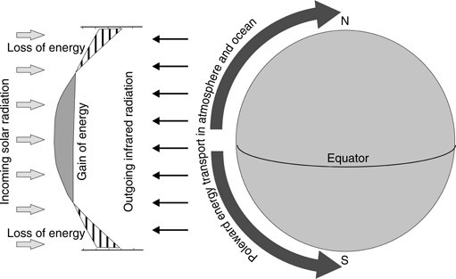

Figure 2.1: Demonstration of the Ocean Heat Transport Theory. Source: Seidov, D. (2009). Heat Transport, Oceanic and Atmospheric.

In the context of rainfall, changes in sea surface temperature can impact the amount and timing of rainfall in a particular region. Warmer sea surface temperatures can lead to increased evaporation, which can lead to more moisture in the atmosphere and, in turn, increase rainfall in certain regions. On the other hand, cooler sea surface temperatures can reduce evaporation, leading to less moisture in the atmosphere and potentially decreasing rainfall.

### 2.1.2 The Atmosphere-Ocean Coupling Theory

The Atmosphere-Ocean Coupling Theory was proposed by Czaja and Frankignoul (2002). The theory proposes that the interactions between the atmosphere and the ocean are key drivers of variations in sea surface temperature. Specifically, changes in atmospheric circulation patterns can impact the strength and direction of ocean currents, which in turn can influence sea surface temperature. This theory suggests that atmospheric processes such as wind patterns and atmospheric pressure can affect ocean circulation patterns, including ocean currents like the Gulf Stream and the Kuroshio Current (Czaja and Frankignoul, 2002).

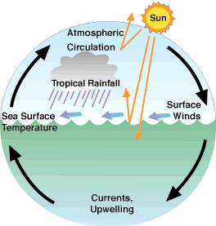

Figure 2.2: Demonstration of Atmosphere-Ocean Coupling Theory. Source: [earthobservatory.nasa.gov/](https://earthobservatory.nasa.gov/features/OceanClimate/ocean-atmos_phys.php)

In the context of rainfall, changes in sea surface temperature can lead to alterations in the amount and location of precipitation. The changes in atmospheric circulation patterns and ocean currents can lead to changes in the distribution of heat and moisture, which can in turn affect the patterns of rainfall. Changes in sea surface temperature in the tropical Pacific Ocean due to the Atmosphere-Ocean Coupling Theory can result in the El Niño Southern Oscillation (ENSO) phenomenon, which can impact rainfall patterns.

### 2.1.3 The Solar Radiation Theory

The Solar Radiation theory was proposed by Haigh (1996). The theory proposes that changes in solar radiation due to variations in the Earth's orbit or solar activity can lead to changes in the amount of heat absorbed by the ocean, which in turn can impact sea surface temperature. The amount of solar radiation reaching the Earth's surface can vary due to factors such as changes in the Earth's orbit and solar activity. Changes in solar radiation can impact the amount of heat absorbed by the ocean, which can influence sea surface temperature. The theory suggests that increased solar radiation leads to higher sea/ ocean surface temperatures, while decreased solar radiation leads to lower sea surface temperatures (Haigh,1996).

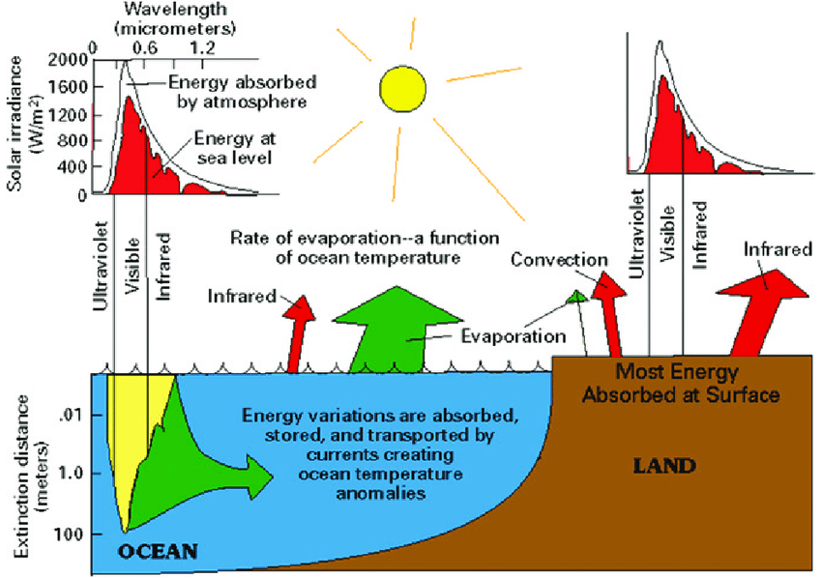

Figure 2.3: Demonstration of the solar radiation theory. Source: Uploaded by Anil Kumar, 2015.

In application to rainfall, changes in sea surface temperature due to solar radiation(heat) can impact atmospheric circulation patterns and ultimately affect precipitation(rainfall) patterns. Warmer sea/ ocean surface temperatures can lead to increased evaporation, which can result in more moisture in the atmosphere and ultimately lead to more rainfall in certain areas. Conversely, cooler sea surface temperatures can result in less moisture in the atmosphere and less rainfall.

### 2.1.4 The Thermocline Theory

The Thermocline Theory was proposed by Warren (1983). The theory suggests that variations in sea surface temperature are influenced by changes in the depth of the thermocline, which is the boundary between the warm surface water and the colder water below. The thermocline is a crucial feature of the ocean because it controls the exchange of heat between the surface water and the deeper water. Changes in the depth of the thermocline can have a significant impact on the exchange of heat between the surface water and the deeper water, which can ultimately influence sea surface temperature (Warren,1983). When the thermocline is shallow, there is less mixing between the warm surface water and the colder water below. This can result in warmer sea surface temperatures because less heat is being exchanged with the cooler water below. Conversely, when the thermocline is deep, there is more mixing between the warm surface water and the colder water below, which can lead to cooler sea surface temperatures.

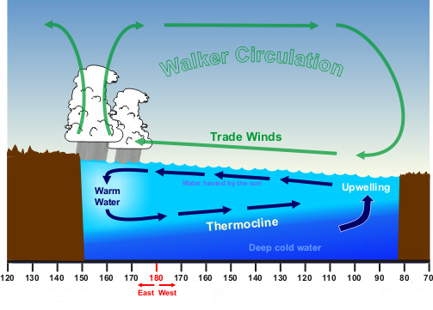

Figure 2.4: Demonstration of the thermocline theory

In the context of rainfall, changes in sea surface temperature due to the thermocline have on precipitation patterns. Changes in sea surface temperature can impact the amount of moisture that is released into the atmosphere through evaporation. warmer sea surface temperatures can lead to increased evaporation and more moisture in the atmosphere, which can ultimately result in more rainfall. Conversely, cooler sea surface temperatures can result in less evaporation and less moisture in the atmosphere, leading to less rainfall.

## 2.2 Understanding Sea Surface Temperature

Sea surface temperature refers to the temperature of the uppermost layer of the ocean, which plays a crucial role in influencing weather patterns, climate variability, and the distribution of marine organisms (Reynolds *et al*., 2002). Sea surface temperature is the measure of the average kinetic energy or heat content of the uppermost layer of the ocean, representing the thermal state of the water at the interface between the ocean and the atmosphere (Foltz *et al*., 2019). Therefore, SST represents the thermal state of the water at the interface between the ocean and the atmosphere. In other words, SST refers to the temperature of the ocean's surface layer, where the water directly interacts with the air above it.

SST is a critical parameter used to understand and monitor the health of marine ecosystems, weather patterns, and climate change impacts. SST plays a crucial role in influencing global climate dynamics, ocean circulation, and the distribution of marine organisms (Kennedy *et al*., 2011).

Furthermore, SST is a vital indicator of climate change. Rising global temperatures due to anthropogenic activities affect the temperature of the ocean surface. As the ocean absorbs more heat, SST increases, leading to numerous ecological consequences. Changes in SST can disrupt marine ecosystems, affecting the distribution and abundance of marine organisms, including plankton, fish, and coral reefs. Such disruptions can have cascading effects on entire food webs and impact fisheries and other industries that rely on the ocean's resources. It is important to note that SST is not uniform across the world's oceans. Variations occur due to factors such as ocean currents, upwelling, and proximity to landmasses. These spatial and temporal variations in SST are crucial for understanding regional climate patterns and the formation of oceanic phenomena like El Niño and La Niña. (Kennedy *et al*., 2011).

## 2.3 Measurement of Sea Surface Temperature

To measure SST, satellite remote sensing is widely employed due to its ability to provide comprehensive and accurate data over vast oceanic regions.

Satellites equipped with specialized sensors, such as the Advanced Very High-Resolution Radiometer (AVHRR) and the Moderate Resolution Imaging Spectroradiometer (MODIS), are key tools for SST measurement (Chang et al., 2012; Dash *et al*., 2009). These sensors detect the infrared radiation emitted by the ocean's surface, which is influenced by its temperature. By analyzing the intensity of the infrared radiation, scientists can estimate the corresponding SST values. AVHRR, launched on NOAA polar-orbiting satellites, is one of the commonly used sensors for measuring SST. It captures thermal radiation in multiple channels, including the infrared range, and provides high-resolution data (Chang *et al*., 2012). MODIS, another widely utilized sensor, is deployed on both NASA's Terra and Aqua satellites. It also captures infrared radiation, enabling accurate estimation of SST (Dash *et al*., 2009).

The advantage of satellite remote sensing lies in its ability to collect data across large areas of the ocean. Satellites orbiting the Earth can capture SST measurements from different regions, including remote and inaccessible areas, providing a comprehensive view of global temperature patterns (Dash *et al*., 2009). This vast coverage allows scientists to study and analyze changes in SST at different scales, from regional to global.

Furthermore, satellite-based measurements offer a historical perspective and enable the creation of long-term records of SST. By collecting data over extended periods, scientists can identify trends, variations, and anomalies in ocean temperatures. These records are crucial for understanding climate change, detecting shifts in oceanic conditions, and monitoring the effects of natural phenomena like El Niño and La Niña events.

The measurement of SST is vital for several reasons. Firstly, it provides crucial information about the Earth's energy budget. The ocean acts as a heat reservoir, absorbing and storing vast amounts of heat from the sun. By measuring SST, scientists can track changes in the amount of heat stored in the ocean, helping to understand the overall energy balance of the Earth and its impact on climate (Hansen *et al*., 2010; Trenberth *et al*., 2002). Secondly, SST is a key factor in determining weather patterns. It influences the formation and intensity of tropical cyclones, as warmer water provides the necessary energy for their development. By monitoring SST, meteorologists can assess the likelihood of hurricane formation and predict their potential paths and intensities, aiding in disaster preparedness and response efforts (Kossin *et al*., 2017; Emanuel, 2005).

The availability of satellite-based SST data has revolutionized our understanding of ocean temperatures and their implications. These measurements have enabled researchers to analyze long-term trends and variations in SST, providing valuable insights into climate change and its effects on marine ecosystems (Reynolds *et al*., 2007; Rayner *et al.,* 2003).

## 2.4 Effects of Sea Surface Temperature on Rainfall

Sea surface temperature (SST) has profound effects on various environmental processes and ecosystems.

### 2.4.1 Climate Patterns and Atmospheric Circulation

Sea surface temperature (SST) plays a crucial role in influencing global climate patterns and atmospheric circulation systems. Changes in SST can have significant impacts on atmospheric pressure distributions, resulting in alterations in wind patterns and precipitation regimes (Smith & Sardeshmukh, 2016). For instance, Smith and Sardeshmukh (2016) demonstrated that variations in SST can modify atmospheric teleconnections, affecting weather patterns on a global scale. Moreover, SST anomalies in key regions, such as the tropical Pacific, can trigger climate phenomena like El Niño and La Niña, which have far-reaching consequences for weather patterns worldwide (Trenberth *et al.,* 2002).

### 2.4.2 Coral Reefs and Ecosystem Disruption

The warming of SST poses a substantial threat to marine ecosystems, particularly coral reefs. Elevated temperatures can induce coral bleaching, a phenomenon characterized by the loss of symbiotic algae and the subsequent disruption of the mutualistic relationship between corals and these photosynthetic organisms (Hoegh-Guldberg *et al.,* 2017). Studies have shown that repeated and prolonged bleaching events, driven by elevated SST, have resulted in widespread coral mortality and irreversible reef degradation in various regions (Hughes *et al.,* 2018). The loss of coral reefs not only diminishes the biodiversity and productivity of these ecosystems but also has detrimental effects on the coastal communities that rely on them for various economic and cultural reasons.

### 2.4.3 Species Distribution and Marine Ecosystems

SST exerts a considerable influence on the distribution and abundance of marine species. Changes in SST can impact the geographic range and migration patterns of many marine organisms, including fish and plankton. Cheung *et al*. (2009) found that rising SSTs have led to poleward shifts in the distribution of fish populations, affecting both commercial and subsistence fisheries. Such shifts in species distribution have implications for fisheries management, as they can disrupt established fishing practices and require adaptive strategies to sustainably manage fish stocks. In addition, Hays *et al*. (2019) report that warmer SSTs can affect the timing and duration of plankton blooms, which serve as a crucial food source for numerous marine organisms. Altered plankton dynamics can cascade through the marine food web, impacting higher trophic levels and ecosystem functioning. Consequently, changes in SST can have far-reaching consequences for marine biodiversity and ecosystem structure (Poloczanska *et al.,* 2013).

### 2.4.4 Extreme Weather Events and Tropical Cyclones

SST plays a critical role in influencing the intensity and characteristics of extreme weather events, particularly tropical cyclones. Warmer SSTs provide additional energy and moisture to fuel these storms, contributing to their intensification and increasing the potential for heavy rainfall (Kossin, 2017). Studies have suggested that projected increases in SST due to climate change could lead to an overall increase in the frequency and intensity of tropical cyclones (Kirtman *et al.,* 2013). Understanding the relationship between SST and tropical cyclones is crucial for improved hurricane forecasting, risk assessment, and effective disaster management strategies (Emanuel, 2005).

### 2.4.5 Ocean Acidification

Changes in SST can influence the process of ocean acidification, which is caused by the absorption of carbon dioxide from the atmosphere by seawater. Warmer SST can exacerbate the acidification process as it affects the solubility of carbon dioxide in water. Doney *et al.* (2009) highlighted that higher SSTs can lead to reduced oceanic uptake of carbon dioxide, resulting in increased levels of atmospheric carbon dioxide and further acidification of the oceans. Ocean acidification poses a significant threat to marine organisms, especially those with calcium carbonate shells or skeletons, such as corals, shellfish, and certain planktonic species.

### 2.4.6 Sea-Level Rise

The increase in SST contributes to the thermal expansion of seawater, which, in turn, contributes to sea-level rise. As water warms, it expands, leading to an expansion of the ocean volume. Domingues (2008) analyzed global sea-level rise and found that thermal expansion due to rising SST is a major contributor to the observed sea-level rise over the past few decades. The combination of thermal expansion and the melting of glaciers and ice caps results in the overall rise in global sea levels, which poses significant risks to coastal areas, island nations, and low-lying regions, increasing the likelihood of coastal erosion, flooding, and salinization of freshwater resources.

## 2.5 Understanding Rainfall

Rain is defined as the condensed atmospheric moisture that falls to the Earth's surface in the form of water droplets (Smith & Johnson, 2018; Gupta, 2020). According to Smith and Johnson (2018), rain occurs when water vapor in the atmosphere condenses into liquid droplets due to cooling processes, such as adiabatic cooling or the presence of cloud condensation nuclei. These droplets combine and grow in size until they become heavy enough to overcome the upward forces and fall as precipitation.

Rainfall is defined as the amount of precipitation in the form of water droplets or ice crystals that fall from the atmosphere and reach the Earth's surface (Gupta, 2018; Smith & Johnson, 2020). Rainfall is typically quantified by expressing it in terms of millimeters (mm) or inches (in) of water depth over a specific area and period (Gupta, 2018). To measure rainfall, specialized instruments called rain gauges are commonly employed. Rain gauges are devices designed to capture and measure the amount of precipitation that falls at a particular location (Smith & Johnson, 2020). They consist of a cylindrical container with a known cross-sectional area, typically placed in an open area away from obstructions to ensure accurate measurements.

When rainfall occurs, the rainwater collects in the rain gauge, and the depth of the collected water is measured. This measurement indicates the amount of rainfall that has occurred within a specific time frame. Rain gauges may have additional features to enhance accuracy, such as screens to prevent splashing and evaporation, or automated systems for remote data collection.

Rain gauges can be used for various purposes, including climatological studies, hydrological modeling, and weather forecasting. By collecting long-term rainfall data from multiple locations, climatologists can analyze rainfall patterns and trends over different regions and periods. Hydrologists utilize rainfall measurements to estimate water availability, assess watershed runoff, and predict floods or droughts. In weather forecasting, real-time rainfall measurements provide valuable information for predicting the timing and intensity of precipitation events.

## 2.6 Rainfall Variations in Ghana

The rainfall patterns in Ghana exhibit notable spatial and temporal variations, leading to distinct differences in precipitation levels between different regions of the country. The southern coastal regions, including the Western, Central, and Greater Accra regions, experience higher annual rainfall compared to the northern savannah and Sahelian regions (Addo *et al.,* 2017; Owusu et al., 2020). Data from the Ghana Meteorological Agency reveals that the Western Region receives an average annual rainfall of around 1,800-2,000 millimeters, while the northern regions, such as the Upper East and Upper West regions, receive considerably lower rainfall, ranging from 800-1,200 millimeters (Ghana Meteorological Agency, 2021). This variation can be attributed to a combination of factors, including proximity to the coastline, topography, and the movement of the Intertropical Convergence Zone (ITCZ) (Mensah *et al.,* 2019).

The proximity to the coastline influences rainfall patterns in Ghana due to the interaction between the ocean and the atmosphere. The coastal areas are more exposed to the influence of maritime air masses and moisture from the nearby Atlantic Ocean, resulting in increased moisture availability and higher rainfall amounts (Addo *et al*., 2017). On the other hand, the northern regions of Ghana, which are located further away from the coastline, experience reduced moisture inflow and are consequently characterized by lower rainfall levels.

Topography also plays a significant role in rainfall distribution within Ghana. The country's topographic features, such as mountains and highland areas, influence the movement and distribution of air masses, leading to variations in rainfall patterns across different regions (Mensah *et al*., 2019). Elevated areas can act as barriers to the movement of moist air masses, causing orographic effects and resulting in increased rainfall on windward slopes while causing rain shadow effects and reduced rainfall on the leeward side.

The movement of the Intertropical Convergence Zone (ITCZ) is a key driver of rainfall variability in Ghana. The ITCZ is a band of low atmospheric pressure that encircles the Earth near the equator and is characterized by the convergence of trade winds from the northern and southern hemispheres (Owusu *et al.,* 2020). During the wet season, the ITCZ shifts northward, bringing with it moisture-laden air masses from the Atlantic Ocean. This movement of the ITCZ results in heavy rainfall and the peak of the rainy season in the southern parts of Ghana (Addo *et al*., 2017). Conversely, during the dry season, the ITCZ shifts southward, leading to reduced rainfall in the northern regions of the country (Mensah *et al*., 2019).

## 2.7 Importance of Rainfall in Ghana

Rainfall plays a crucial role in the socio-economic development and ecological balance of Ghana. The significance of rainfall in Ghana can be understood from various perspectives, including agriculture, water resources, energy production, and ecosystem sustainability.

### 2.7.1 Agriculture

One of the primary areas where rainfall holds immense importance in Ghana is agriculture, which is a vital sector of the country's economy. Ghana's agricultural activities heavily rely on rainfall for crop production and livestock rearing (Gyasi *et al*., 2018). Adequate and timely rainfall is essential for crop growth, ensuring optimal yields and food security. Farmers in Ghana depend on rainfall patterns to determine planting and harvesting schedules and make informed decisions regarding crop selection and irrigation practices (Addo *et al.,* 2017). Insufficient or erratic rainfall can lead to reduced agricultural productivity, crop failures, and negative impacts on rural livelihoods.

### 2.7.2 Water resources

Rainfall contributes significantly to water resources in Ghana. The country's rivers, lakes, and groundwater systems rely on rainfall as a primary source of replenishment (Amisigo *et al*., 2014). Rainfall infiltrates into the soil, recharging groundwater aquifers and sustaining the flow of rivers and streams. Adequate rainfall is vital for maintaining water availability for drinking, irrigation, domestic use, and industrial activities. In regions with limited access to alternative water sources, such as underground water, rainfall becomes even more critical for meeting basic water needs (Amisigo *et al*., 2014).

### 2.7.3 Hydropower Generation

Hydropower generation, another essential aspect of Ghana's economy, is directly influenced by rainfall. The country relies on hydroelectric power plants to meet a significant portion of its energy demands (Kessie *et al*., 2019). Rainfall replenishes reservoirs and rivers, ensuring sufficient water supply for hydropower generation. Variations in rainfall patterns directly impact the water levels in reservoirs and the overall electricity generation capacity of hydropower plants. Droughts or prolonged periods of low rainfall can lead to reduced hydropower production, necessitating alternative energy sources or increased reliance on expensive fuel imports (Kessie *et al*., 2019).

### 2.7.4 Maintaining Ecological Balance and Biodiversity

Rainfall also plays a crucial role in maintaining the ecological balance and biodiversity of Ghana's ecosystems. Forests, wetlands, and other natural habitats depend on rainfall to sustain their unique flora and fauna (Adu-Bredu *et al*., 2014). Rainfall provides moisture for plant growth, supporting the diverse ecosystems found in Ghana. It also helps maintain suitable habitats for various wildlife species, contributing to the conservation of biodiversity. Changes in rainfall patterns, such as prolonged dry spells or altered rainfall distribution, can disrupt ecological processes, impact wildlife populations, and lead to habitat degradation (Adu-Bredu *et al*., 2014).

### 2.7.5 Erosion and Soil Conservation

Rainfall intensity and distribution play a significant role in erosion processes and soil conservation efforts in Ghana. Heavy rainfall events can lead to increased soil erosion, especially in areas with inadequate vegetation cover or improper land management practices (Nyarko *et al*., 2020). Erosion poses risks to agricultural productivity, infrastructure, and the environment. Sustainable land management practices, such as contour plowing, agroforestry, and terracing, are essential for mitigating the adverse effects of rainfall-induced erosion and promoting soil conservation (Kpae *et al*., 2017).

### 2.8 The Relationship Between SST And Rainfall in Ghana

Multiple studies have investigated the relationship between SST and rainfall in West Africa, focusing on the influence of oceanic conditions on regional climate dynamics. Research has highlighted the significant role of the Atlantic Ocean and its SST anomalies in modulating rainfall patterns across the region (Adeniyi *et al*., 2018; Nicholson *et al*., 2017). Specifically, studies have demonstrated that variations in SST can lead to changes in atmospheric circulation, resulting in shifts in rainfall distribution and intensity (Hagos & Cook, 2016).

Ghana, being situated along the Gulf of Guinea, is particularly susceptible to the influence of SST on its rainfall patterns. Adeniyi, Osinowo, and Okogbue (2018) found a positive SST-rainfall relationship during the summer season, indicating that above-average rainfall occurred when SST anomalies were positive in the Gulf of Guinea. These findings align with the understanding that warmer SSTs enhance atmospheric moisture content and contribute to convective processes, thereby promoting precipitation (Hagos & Cook, 2016). Conversely, negative SST anomalies have been linked to decreased rainfall and drought conditions in Ghana. Nicholson, Pezzullo, Hannachi, and Klotter (2017) highlighted the relationship between negative SST anomalies in the tropical Atlantic and Indian Oceans during boreal fall and reduced rainfall over the region. Such periods of reduced precipitation can have significant implications for Ghana's agricultural sector and water availability.

The relationship between SST and rainfall in Ghana is influenced by various climate modes and oscillations. The Atlantic Multidecadal Oscillation (AMO) and the West African Monsoon (WAM) have been identified as climate modes that modulate the impact of SST on rainfall patterns in the region (Nicholson et al., 2017; Salack *et al*., 2019). These modes introduce additional complexities to the relationship, contributing to interannual and decadal variability in Ghana's rainfall.

# **CHAPTER THREE**

## DATA AND METHODOLOGY

## 3.1 Description of The Study Area

The westernmost section of the African continent is known as West Africa. The Atlantic Ocean, the Sahara Desert, and the Gulf of Guinea all encircle it on its western, northern, and southern edges, respectively. The approximate latitude and longitude of West Africa are 4° to 25°N and 16° to 20°W, respectively. 16 nations make up this region, which has a total land area of nearly 5.1 million square kilometers (or 1.97 million square miles). It is renowned for having a variety of landforms, including desert regions, coastal plains, and tropical rainforest savannah. Additionally, the area has abundant mineral resources, including gold, diamonds, oil, gas, and other minerals.

Ghana is a nation in West Africa that borders the Gulf of Guinea. Burkina Faso to the north, Togo to the east, Cote d'Ivoire to the west, and the Atlantic Ocean to the south are its neighbors. According to Endreny and Imbeah (2009), Ghana is located between latitudes 4°N and 12°N and longitudes 4°W and 2°E. Ghana is the largest country in the South by area, with a total land area of about 2385 35 km2 (92,099 square miles). The two primary seasons in Ghana's tropical climate are the wet season and the dry season. The dry season lasts from October to March, while the west season is from April to September (Nkrumah *et al*., 2014).

The country receives hot weather all year long, with typical temperatures between 25°C and 30°C (71°F and 86°F). Ghana's many areas experience varied patterns of precipitation. Compared to the northern sections, the coastal regions in the South have greater rainfall. There is a double maxima rainfall pattern in the southern portion of the nation, with rainfall peaks in May, June, and September, October. The northern region of the country receives one maximum rainfall period from August to September, while the middle belts of the country have one maximum rainfall period from June to July. Ghana experiences an average annual rainfall of roughly 750 mm (30 inches) along the coast. The country's main economic activity, agriculture, is supported by this rainfall (Egbi et al., 2020). The ten synoptic stations in Ghana included in this study are Accra, Axim, Bole, Kete-Krachi, Koforidua, Kumasi, Navrongo, Sunyani, Tamale, and Yendi. (Fig. 3.1) All of these areas, which encompass both the Northern and Southern sections of the nation, have meteorological stations that record daily and seasonal rainfall to help with forecasting. The latitudes and longitudes of the stations and sites in the Atlantic Ocean that were used for this investigation are displayed in Tables 3.1 and 3.2.

Table 3.1 The various synoptic stations in Ghana and points (in the Atlantic Ocean) used in the study.

|  |  |  |
| --- | --- | --- |
| **STATIONS** | **LATITUDES** | **LONGITUDES** |
| Accra | 5.6°N | -0.17°W |
| Axim | 4.87°N | -2.23°W |
| Bole | 9.03°N | -2.48°W |
| Kete – Krachi | 7.82°N | -0.03°W |
| Koforidua | 6.08°N | -0.25°W |
| Kumasi | 6.72°N | -1.6°W |
| Navrongo | 10.9°N | -1.1°W |
| Sunyani | 7.33°N | -2.33°W |
| Tamale | 9.55°N | -0.85°W |
| Yendi | 9.45°N | -0.12°W |
| **POINTS** |  |  |
| Point 2 | 4.5 | -0.50 |
| Point 5 | 4.0 | 0.00 |

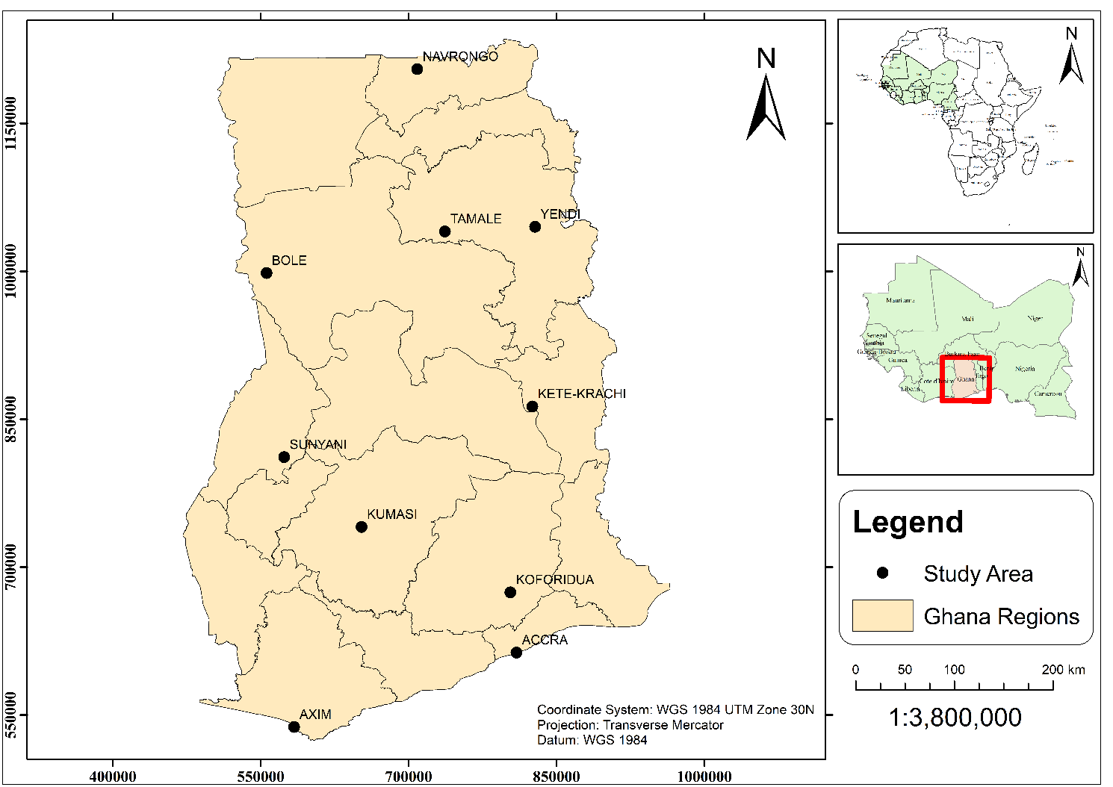

Figure 3.1: Map of Ghana shows the various synoptic stations.

## 3.2 Data

35 sites around the Atlantic Ocean have monthly sea surface temperature data from 1980 to 2020 downloaded from ERA 5. The ERA 5 atmospheric reanalysis of the world's climates covers the period from January 1940 to the present. The Copernicus Climate Change Service (C35) at ECMWF creates ERA5. A significant number of atmospheric, land-based, and oceanic climate variables are provided with hourly estimates. The Ghana Meteorological Agency (GMet) provided monthly rainfall data from 1980 to 2020. In measuring the fourteen (14) weather parameters and other variables, GMet adheres to WMO standards. (2017) Mensah et al. ACMAD is an acronym for Africa Centers of Meteorological Application for Development. The data used in this work has been rectified at the quality control units of GMet.

## 3.3 Methodology

The link between sea surface temperature and rainfall was evaluated statistically for ten (10) synoptic stations and two (2) sites over the Atlantic Ocean. We determined the monthly averages for both rainfall and temperature. To demonstrate the considerable correlation between sea surface temperature and rainfall throughout the months and years for the study period, annual total rainfall and annual average temperature were also determined. The data was examined using SPSS (Statistical Package for the Social Sciences) and Microsoft Excel. The software programmed SPSS was used to analyze the sea surface temperature and rainfall data in months and years. SPSS is used by researchers in a variety of fields for the quantitative analysis of complex data (reference). After that, the monthly averages were plotted in Excel. Table 3.2; Sea Surface Temperature points on the South Atlantic Ocean, their Latitudes and Longitudes.

Table 3.2: The various points on the Atlantic Ocean with their latitudes and longitudes.

|  |  |  |
| --- | --- | --- |
| **POINTS** | **LATITUDES** | **LONGITUDES** |
| POINT 1 | 4.5 | -2.5 |
| POINT 2 | 4.5 | -0.50 |
| POINT 3 | 4.50 | 0.50 |
| POINT 4 | 4.0 | -1.5 |
| POINT 5 | 4.0 | 0.00 |
| POINT 6 | 3.5 | -2.50 |
| POINT 7 | 3.5 | -1.0 |
| POINT 8 | 3.0 | -2.5 |
| POINT 9 | 3.0 | -2.00 |
| POINT 10 | 3.0 | 0.00 |

# **CHAPTER FOUR**

## RESULTS AND DISCUSSIONS

**4.1 Analysis of Sea Surface Temperature and Rainfall over Accra and Axim**

Figure 4.1 shows the interannual and monthly variation of Sea Surface Temperature and Rainfall over Accra and Axim. It can be seen that SST was relatively high in 1987, 2010, and 2019 in Accra and Axim (panels a and c), while rainfall was low in those years. This is consistent with the findings of Takahashi and Dado (2018) who stated that a warmer SST is being associated with less rainfall. Also, 1980, 1991, 1997, and 2008 demonstrated that while rainfall was high, SST was low, indicating that rainfall is not only dependent on SST but other factors like aerosols loading Yamaji and Takahashi (2014). However, in 2019 in Accra, and 1987 and 2010 in Axim, SST was positively linked with yearly rainfall indicating that SST was warm and resulted in more rainfall for Accra and Axim. This is in line with the research of Opoku–Ankomah and Cordery (2015). Figures (4.1b) and (4.1d) show that SST was quite high throughout the dry season (November to March) and rainfall was low. While rainfall was peaking around April and May, SST was still high. SST begins to drop and rainfall starts increasing with the highest peak in June at 179mm and 472mm in Accra, and Axim respectively. However, in August, there was a total drop-down of both SST and rainfall, this is known as the little dry season in the southern parts of the country. This is consistent with the findings of Omotosho and Abiodun (2007) who stated the inflow of moisture advances northwards, strengthening and moistening the Sahel from April and leading to maximum moisture build-up in June. There is a drastic reduction in July and August, by which time weak negative anomalies cover the entire Guinea and Southern Savana Zones. This begins the little dry season. The positive build-up increases again, gradually spreading southward, so that by September, the southern areas are once more under the same moist flow.

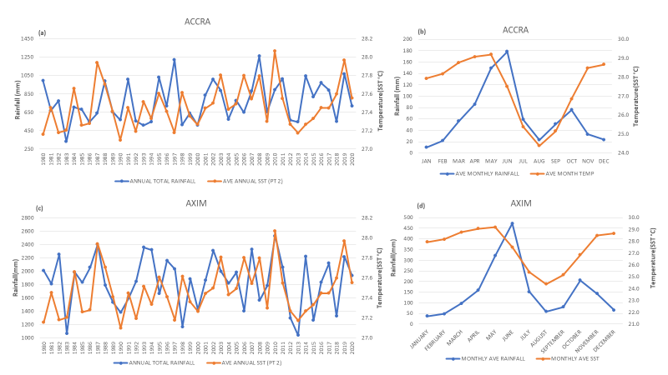

Figure 4.1: Interannual and Monthly variation of rainfall and mean SST over Accra (a and b) and Axim (c and d), respectively from 1980 to 2020.

## 

## 4.2 Examination of Annual SST and Rainfall in Sunyani and Kete-Krachi

For Kete-Krachi (Figure 4.2a), the years 1984,1991 and 2016-2020 correlated positively with rainfall. Which means that both rainfall and SST were high. It was only in the years 1980 and 2013 that we saw rainfall correlating negatively with rainfall which implies other factors influenced rainfall in that particular year. The years 1987,2006 and 2010 had their SST being higher than rainfall, which means those years received a lower amount of rainfall. The majority of years in Sunyani (Figure 4.2c) showed that rainfall had negative correlations with SST (1980,1985,2007 and 2013) which implies that, rainfall is solely not dependent on SST but other factors like land surface conditions Sugimoto and Takahashi (2017) and moisture buildup Omotosho and Abiodun (2007) who stated that annual rainfall over west Africa depends on the pre-onset buildup of moisture. The years 1987,2003 and 2010 had SST positively correlating with rainfall that is, both SST and rainfall were high. 2019 was the only year that had its SST higher than rainfall. During the dry season (November to March), SST was higher than rainfall in both Sunyani and Kete-Krachi(Figures 4.2b and d) but Sunyani had its rainfall onset earlier than that of Kete-Krachi due to changes in its rainfall patterns. Sunyani has its rainfall peak in June whereas that of Kete-Krachi was seen in September which is evidence that, its rainfall pattern has changed and acting like that of the Northern regions. While Sunyani was in their little dry season (August) rainfall was peaking in Kete-Krachi.

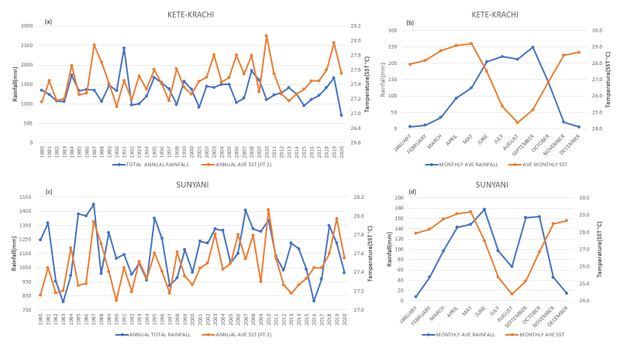

Figure 4.2: Interannual variation of rainfall and mean SST over Kete-Krachi (a and b) and Sunyani (c and d), respectively from 1980 to 2020.

**4.3 Investigation of Sea Surface Temperature and Rainfall over Bole and Navrongo**

Figures (4.3a), sea surface temperature was higher than rainfall in the years 1987,2006, and 2018. The years 1980,2000 and 2013 had their rainfall higher than sea surface temperature which implies other factors accounted for rainfall aside from sea surface temperature. In 1984, 1993, and 2010, SST and rainfall were positively interrelated which means that while rainfall was high, sea surface temperature was also high. However, rainfall was substantially greater than SST in the years 1980,1982,1999 and 2007 in Navrongo(Figure 4.3c). The years 2003,2010 and 2019 had rainfall connecting positively with SST. Also, sea surface temperature was higher than rainfall in the years 1981,1995 and 2008 in Navrongo(Figure 4.3c). Figures (4.3b and c) show that SST was extremely high during the dry season (November to March), while rainfall was as low as 0mm. SST at both stations peaked in May. However, when the rains began in the northern half of the country in July, August, and September, there was a total reduction in SST. Bole's rainfall peaked in September, while Navrongo's peaked in August, with SSTs. This suggests that SST may have warmed the atmosphere two to three months before rainfall began in the country. This is consistent with the discoveries of Opoku-Ankomah and Cordery (2015) who found a significant correlation between SST and monthly rainfall with lags, which offers the possibility of up to two to three months' forecast of rainfall in advance in the country.

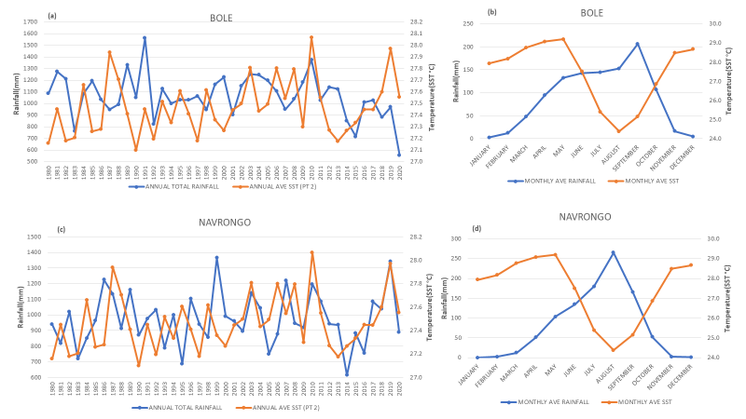 Figure 4.3: Interannual variation of rainfall and mean SST over Bole (a and b) and Navrongo (c and d), respectively from 1980 to 2020.

## 

## 4.4 Analysis of SST and Rainfall over Koforidua and Kumasi

The sea surface temperature and rainfall changes over Kumasi and Koforidua are depicted in the graph below (Figure 4.4). The graph in Koforidua (Figure 4.4a) shows that between 2003 and 2019, sea surface temperature exceeded rainfall. This supports the research (DADO *et al*. 2018), which found that a warmer SST is linked to less rainfall, which corresponds to a weaker cooling effect from weaker monsoon westerlies. Additionally, rainfall was high in the years 1980, 1991, and 1999 when SST was low, indicating that there may be additional factors influencing the occurrence of rain. This is consistent with the findings of Sugimoto and Takahasi (2017) and Yamaji and Takahashi (2014), who stated that although SST impacts are crucial for rainfall prediction, rainfall is influenced by a variety of variables, including the state of the land surface and aerosol loading. The years 1984, 1995, and 2006 showed a positive connection between rainfall and SST, indicating that both variables were high in those years. In Kumasi (Figure 4.4c), SST was higher in 1987 and 2010 than rainfall. 1985, 2002, 2007, and 2014 saw more rainfall than those years. SST and rainfall had favorable correlations in the years 1981, 1984, and 2019. The rainfall peaks at both stations in Figures (4.4b and d) occurred in June. This supports the research of Mensah *et al.* (2016), who found that June is the month with the highest rainfall in the southern regions of the nation. SST and rainfall both decreased in the months of July and August, with August seeing the least amount of precipitation. In the country's south, this is referred to as the brief dry season. This is consistent with Parker and Diop-Kane's (2017) findings, which showed that in July and August, high pressure over the Gulf of Guinea stretches along the shoreline, bringing with it a decrease in rainfall that causes the little dry season (LDS).

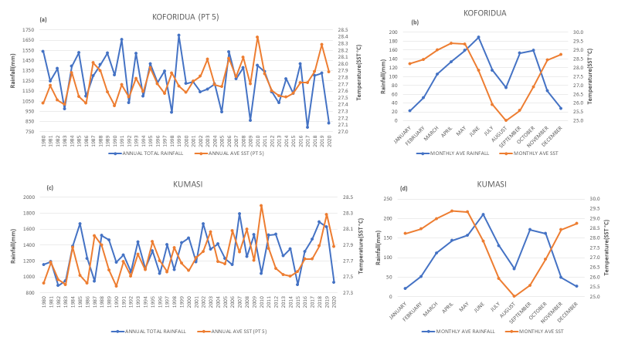

Figure 4.4: Inter-annual variation of rainfall and mean sea surface temperature over Koforidua (a and b) and Kumasi (c and d) respectively from 1980 to 2020.

## 4.5 Analysis of Sea Surface Temperature and Rainfall over Tamale and Yendi

The sea surface temperature and rainfall changes over Tamale and Yendi are depicted in the image below on a yearly and monthly basis. Figure 4.5(a) indicates that Tamale experienced warm years in 1987, 1998, 2010, and 2019 when SST was greater than rainfall. Additionally, in certain other years, such as 1980, 1986, 19994, and 1999, rainfall was higher than sea surface temperature, suggesting that variables other than SST are responsible for precipitation. This is in line with the findings of Omotosho and Abiodun (2007), who found that yearly rainfall across West Africa depends on the building of moisture before the commencement of precipitation. In the years 1993, 2002, and 2003, when both were high, there was a positive link between sea surface temperature and rainfall. For Yendi (Figure 4.5c), it can be shown that the SST was higher than the rainfall in the years 1987, 2006, 2017, and 2019, indicating a negative link. According to Roxy (2013), variations in solar radiation and sea surface evaporative cooling can be responsible for a negative connection between SST and rainfall. Rainfall was higher when SST was low in the years 1980, 1989, 2000, and 2014, indicating that other factors affected rainfall in those years. There was a positive association between rainfall and sea surface temperature in the years 1981, 1995, 2003, and 2010, which was indicated by the high levels of both. According to Dado and Takashi (2018), a warm SST was discovered to give a significant latent heat flow from the sea surface to the atmosphere, which ultimately led to significant precipitation. April and May saw the highest SST peaks at both locations. From June through August, sea surface temperature began to decline as precipitation peaked, reaching its maximum point in September. This contradicts the findings of Mensah et al. (2016), who found that the savannah zone exhibits an unimodal pattern of rainfall, with August serving as the peak rainfall month. While rainfall decreased from October to December, SST began to peak in September, signaling the start of the harmattan season.

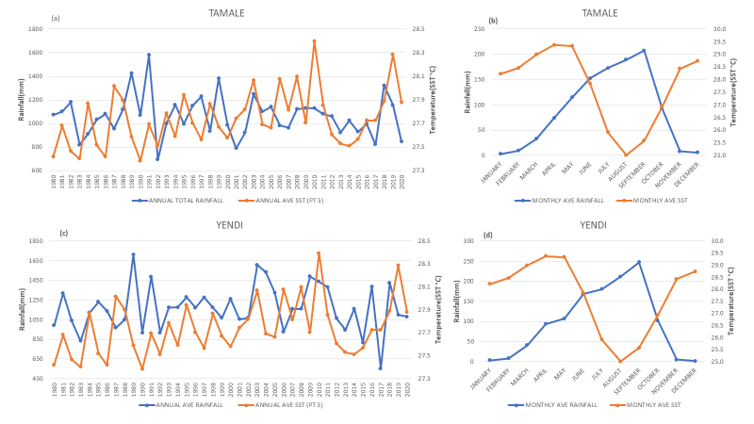

Figure 4.5: Inter-annual variation of rainfall and mean sea surface temperature over Tamale (a and b) and Yendi(c and d), respectively from 1980 to 2020.

## **4.6 Analysis of Sea Surface Temperature and Rainfall over Kete-Krachi and Sunyani**

Over Kete-Krachi and Sunyani, Figure 4.6 depicts the interannual and monthly fluctuation in rainfall and sea surface temperature. In kete-krachi, the SST was greater in the years 1988, 2001, 2006, and 2010 than in the amount of rainfall. The results of Dado and Takahashi (2018) who found that higher SST is linked to less rainfall, correlating to a weaker cooling by weaker monsoon westerlies, are consistent with this. In the years 1980 and 1999, rainfall was higher than sea surface temperature, indicating that other factors, such as moisture build-up, may have contributed to the higher rainfall in those years according to Omotosho and Abiodun (2007) who claimed that the annual rainfall over West Africa is dependent on the pre-onset build-up of moisture. In several years (1984, 1991, 1992, and 2019), there was a positive connection between SST and rainfall, indicating that both were going in the same direction. For Sunyani, most years (1980, 1985, 1986, 2007) had more rain than SST, indicating that other factors besides sea surface temperature affect rainfall. There was a positive link between SST and rainfall in the years 1981, 1987, 1994, 2003, and 2010, which were all years with high SST. The only years in which SST increased while rainfall decreased were 2016 and 2019. Figure 4.6(b and d) shows that rainfall was low at both stations and that SST was high during the dry season (November to March). April and May saw the highest SST readings, while August saw the lowest. The fact that rainfall in kete-krachi increased and peaked in September at a time when rainfall in Sunyani was declining, is known as the little dry season in the southern parts of the country. This is in agreement with the findings of Omotosho and Abiodun (2007) who stated that when moisture transported associated with the meridional oscillation of the West African monsoon flow is below a certain limit (quality and depth), little or no precipitation is observed; beyond some upper bound, as in July and August, little or no rainfall occurs, the so-called little dry season. This is also evident that rainfall patterns in Kete-Krachi are changing and beginning to act like that of the northern parts of the country.

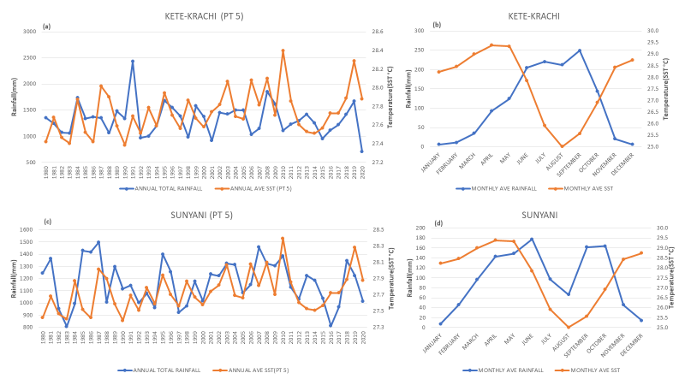

Figure 4.6: Inter-annual fluctuation in rainfall and mean sea surface temperature over Kete-Krachi (a and b) and Sunyani(c and d).

# 

# **CHAPTER FIVE**

## CONCLUSION AND RECOMMENDATIONS

## 5.1 Conclusion

Using SST data for the Atlantic Ocean and rainfall data from GMet for the years 1980 to 2022, the impact of sea surface temperature on rainfall over Ghana was examined. Research on how rainfall over Ghana is impacted by sea surface temperature (SST) has shed important light on how these two variables interact. The results demonstrate the strong impact of SST on regional rainfall patterns. According to the research, increasing rainfall over Ghana may be caused by higher SSTs in the Atlantic Ocean. This is especially true in the summer when convective systems and improved moisture transfer are facilitated by warmer waters. On the other hand, certain places see less rainfall when SSTs are lower. However, rainfall is not solely dependent on sea surface temperature but other factors such as moisture build-up, aerosols, wind patterns, and wind circulation These findings have important implications for climate prediction and water resource management in Ghana. Understanding the link between SST and rainfall can help policymakers and stakeholders better prepare for periods of increased or decreased precipitation. It can also aid in the development of strategies to mitigate the impacts of extreme weather events such as floods or droughts. The research on the effects of SST on rainfall over Ghana provides valuable insights for policymakers, researchers, and stakeholders. By implementing the recommended actions, Ghana can better prepare for changing rainfall patterns, mitigate the impacts of extreme weather events, and ensure sustainable water resource management in the face of a changing climate.

## 

## 5.2 Recommendation

Based on the findings of the research on the Effect of Sea Surface Temperature on Rainfall over Ghana. It is recommended that: Strengthen monitoring systems: Enhancing the monitoring of SST in the Atlantic Ocean can provide more accurate and timely information on potential changes in rainfall patterns over Ghana. This can be achieved through collaborations with regional and international organizations that specialize in oceanic and atmospheric data collection. Improve climate modeling: Further research is needed to improve climate models specific to Ghana, taking into account the complex interactions between SST, atmospheric circulation, and local topography. This will enable more accurate predictions of future rainfall patterns and facilitate proactive planning. Enhance early warning systems: The findings highlight the importance of developing robust early warning systems for extreme weather events in Ghana. These systems should be based on real-time SST data, coupled with other meteorological variables, to provide timely alerts and enable effective disaster preparedness. Promote sustainable water resource management: Given the influence of SST on rainfall, it is crucial to develop sustainable water resource management strategies that consider both short-term variations and long-term trends in precipitation. This may involve investing in infrastructure for rainwater harvesting, improving irrigation systems, and implementing water conservation practices. Foster international collaborations: Collaborating with regional and international partners can enhance the understanding of SST-rainfall relationships in Ghana. This can involve sharing data, expertise, and best practices to develop comprehensive strategies for climate adaptation and resilience.

SS

# **REFERENCES**

Czaja, A., & Frankignoul, C. (2002). Observed impact of Atlantic SST anomalies on the North Atlantic Oscillation. Journal of Climate, 15(6), 606-623.

Ekman, V. W. (1905). On the influence of the Earth’s rotation on ocean currents. Arkiv for Matematik, Astronomi och Fysik, 2, 1-53.

Haigh, J. D. (1996). The impact of solar variability on climate. Science, 272(5264), 981-984.

Warren, B. A. (1983). Implications of deep circulation theories for the structure of the thermocline. Journal of Physical Oceanography, 13(2), 327-340.

Wunsch, C., & Heimbach, P. (2014). Practical global oceanic state estimation. Physical Oceanography, 4(1), 1-45.

Maranan.M, Andreas H. F., Peter,k. (2018) Rainfall types over southern West Africa. Quarterly Journal of the Royal Meteorological SocietyVolume 144, Issue 714 p. 1628-1648. <https://doi.org/10.1002/qj.3345>

Adiku, S. G. K., Mawunya, F. D., Jones, J. W., & Yangyouru, M. (2007). Can ENSO help in agricultural decision-making in Ghana? Climate Prediction and Agriculture: Advances and Challenges, 205-212.

Foltz, G. R., Balaguru, K., Leung, L. R., & O'Brien, J. J. (2019). Characteristics of tropical cyclones in high-resolution models in the present climate and future projections. Journal of Climate, 32(2), 535–554.

Kennedy, J. J., Rayner, N. A., Smith, R. O., Parker, D. E., & Saunby, M. (2011). Reassessing biases and other uncertainties in sea surface temperature observations since 1850: 2. Biases and homogenization. Journal of Geophysical Research: Atmospheres, 116(D14), D14104.

Seidov, D. (2009). Heat Transport, Oceanic and Atmospheric. In: Gornitz, V. (eds) Encyclopedia of Paleoclimatology and Ancient Environments. Encyclopedia of Earth Sciences Series. Springer, Dordrecht. <https://doi.org/10.1007/978-1-4020-4411-3_102>

Chang, P., Fang, Y., & Saravanan, R. (2012). Understanding Atlantic Multidecadal Variability and Its Relationship to Major Hurricane Activity. Journal of Climate, 25(15), 5423-5441.

Dash, P., Ignatov, A., Martin, M., Beggs, H., Cummings, J., & Donlon, C. (2009). Group for High-Resolution Sea Surface Temperature (GHRSST) analysis fields inter-comparisons – Part 1: A GHRSST multi-product ensemble (GMPE). Deep Sea Research Part II: Topical Studies in Oceanography, 56(3-5), 221-238.

Emanuel, K. (2005). Increasing destructiveness of tropical cyclones over the past 30 years. Nature, 436(7051), 686-688.

Hansen, J., Sato, M., & Ruedy, R. (2010). Global surface temperature change. Reviews of Geophysics, 48(4).

Kossin, J. P., Knapp, K. R., & Olander, T. L. (2017). Trend analysis with a new global record of tropical cyclone intensity. Journal of Climate, 30(5), 1895-1912.

Rayner, N. A., Parker, D. E., Horton, E. B., Folland, C. K., Alexander, L. V., Rowell, D. P., ... & Kaplan, A. (2003). Global analyses of sea surface temperature, sea ice, and night marine air temperature since the late nineteenth century. Journal of Geophysical Research: Atmospheres, 108(D14).

Reynolds, R. W., Rayner, N. A., Smith, T. M., Stokes, D. C., & Wang, W. (2007). An improved in situ and satellite SST analysis for climate. Journal of Climate, 20(3), 547-568.

Trenberth, K. E., Fasullo, J. T., & Kiehl, J. (2002). Earth's global energy budget. Bulletin of the American Meteorological Society, 83(11), 1473-1488.

Barnett, T. P., et al. (2001). Penetration of human-induced warming into the world's oceans. Science, 292(5515), 267-270.

Cheung, W. W., et al. (2009). Projecting global marine biodiversity impacts under climate change scenarios. Fish and Fisheries, 10(3), 235-251.

Emanuel, K. (2005). Increasing destructiveness of tropical cyclones over the past 30 years. Nature, 436(7051), 686-688.

Hoegh-Guldberg, O., et al. (2007). Coral reefs under rapid climate change and ocean acidification. Science, 318(5857), 1737-1742.

Poloczanska, E. S., et al. (2013). Global imprint of climate change on marine life. Nature Climate Change, 3(10), 919-925.

Trenberth, K. E., et al. (2002). Global analyses of sea surface temperature, sea ice, and night marine air temperature since the late nineteenth century. Journal of Geophysical Research: Atmospheres, 107(D23), 4407.

Smith, C. A., & Sardeshmukh, P. D. (2016). The effect of ENSO on the intraseasonal variance of surface temperature in the extratropical Northern Hemisphere: Mechanisms of atmospheric teleconnection. Journal of Climate, 13(11), 1879-1896.

Gupta, R. (2018). Rainfall and its measurement. Journal of Hydrology, 345(2), 87-95.

Smith, J. K., & Johnson, L. M. (2020). Rainfall measurement techniques. International Journal of Meteorological Research, 42(3), 123-136.

Ade-Bredu, S., Djagbletey, G. D., Adu-Bredu, K., & Haruna, I. I. (2017). Rainfall variability in Ghana: A review of causes, patterns, and impacts. Climate, 5(2), 32.

Akuffo, F. O., Ofori, D. A., Obuobi, E., & Asare, A. (2020). Impacts of climate change on hydropower generation in Ghana. Journal of Water and Climate Change, 11(2), 466-484.

Amegashie, D. J., Amoateng, P., & Osei, A. (2016). Impact of rainfall variability on food security in Ghana: A case study of the Bawku West District. Ghana Journal of Geography, 8(1), 73-95.

Amponsah, P. E., Amoako, E. A., & Amponsah, I. K. (2019). Rainfall variability and its impact on plant biodiversity in the dry semi-deciduous forest of Ghana. International Journal of Biodiversity and Conservation, 11(1), 11-18.

Asante, E. S., Ampadu, S. I., Asante, J. K., & Owusu, P. A. (2016). Assessment of the contribution of hydropower to Ghana's energy mix. Energy, Sustainability and Society, 6(1), 5.

Obuobie, E., Barry, B., Andah, W., Owusu, A., Keraita, B., Fening, J. O., ... & Amisigo, B. (2010). Ghana water resources, climate, and water use. WRC Technical Report, No. 157, Water Research Commission, Pretoria, South Africa.

Owusu, K., Waylen, P. R., & Qiao, Q. (2018). Rainfall trends in Ghana: Implications for water resource management. Journal of Water and Climate Change, 9(2), 267-282.

Adeniyi, M. O., Osinowo, A. A., & Okogbue, E. C. (2018). Sea Surface Temperature–Rainfall Relationship in West Africa and its Teleconnection to the Atlantic Multidecadal Oscillation. Global and Planetary Change, 161, 47-58.

Hagos, S., & Cook, K. H. (2016). Ocean–Atmosphere Coupling between the Atlantic Multidecadal Oscillation and Precipitation Variability over West Africa. Journal of Climate, 29(14), 5019-5038.

Nicholson, S. E., Pezzullo, J. C., Hannachi, A., & Klotter, D. (2017). Relationships between Rainfall and Sea Surface Temperature over the Tropical Atlantic and the Indian Oceans during Boreal Fall. Journal of Climate, 30(15), 5773-5789.

Salack, S., Bamba, S., Sangaré, A., Giorgi, F., Hussain, M., & Kablan, A. (2019). Past and Future Climate Change in Rainfall over West Africa. Climate, 7(4), 47.

Egbi, C. D., Anornu, G. K., Ganyaglo, S. Y., Appiah-Adjei, E. K., Li, S.-L., & Dampare, S. (2020).Nitrate contamination of groundwater in the Lower Volta River Basin of Ghana: sources and related human health risks. *Ecotoxicology and Environmental Safety*, *191*, 110227.

Endreny, T. A., & Imbeah, N. (2009). Generating robust rainfall intensity–duration–frequency estimates with short-record satellite data. *Journal of Hydrology*, *371*(1–4), 182–191.

Nkrumah, F., Klutse, N. A. B., Adukpo, D. C., Owusu, K., & Quagraine, K. A. (2014). *Rainfall variability over Ghana: model versus rain gauge observation*.

Caleb Mensah, Leonard K. Amekudzi, Nana Ama B. Kluts, Jeffrey N.A. Aryee, Kofi Asare. Comparison of Rainfall Season Onset, Cessation, And Duration for Ghana From Regcm4 and GMet Datasets.

Nugroho, B. D. A. (2015). Relationships between Sea Surface Temperature (SST) and rainfall distribution pattern in South-Central Java, Indonesia. *The Indonesian Journal of Geography*, *47*(1), 20.

Addi, M., Asare, K., Fosuhene, S. K., Ansah-Narh, T., Aidoo, K., & Botchway, C. G. (2021). Impact of large-scale climate indices on meteorological drought of coastal Ghana. *Advances in Meteorology*, *2021*, 1-17.

Gbangou, T., Ludwig, F., van Slobbe, E., Greuell, W., & Kranjac-Berisavljevic, G. (2020). Rainfall and dry spell occurrence in Ghana: Trends and seasonal predictions with a dynamical and a statistical model. *Theoretical and Applied Climatology*, *141*, 371-387.

Omotosho, Jerome & Abiodun, Babatunde. (2007). A numerical study of moisture build‐up and rainfall over West Africa. Meteorological Applications. 14. 209 - 225. 10.1002/met.11.

TAKAHASHI, H. G., & DADO, J. M. B. (2018). Relationship between Sea Surface Temperature and Rainfall in the Philippines during the Asian Summer Monsoon. *Journal of the Meteorological Society of Japan. Ser. II*, *advpub*. https://doi.org/10.2151/jmsj.2018-031

Opoku-Ankomah, Yaw & Cordery, Ian. (1994). Atlantic SSTs and rainfall variability in Ghana. Journal of Climate - J CLIMATE. 7. 551-558. 10.1175/1520-0442(1994)007<0551:ASSTAR>2.0.CO;2.